Network

Ahmed Ehab Ahmed
Lab1

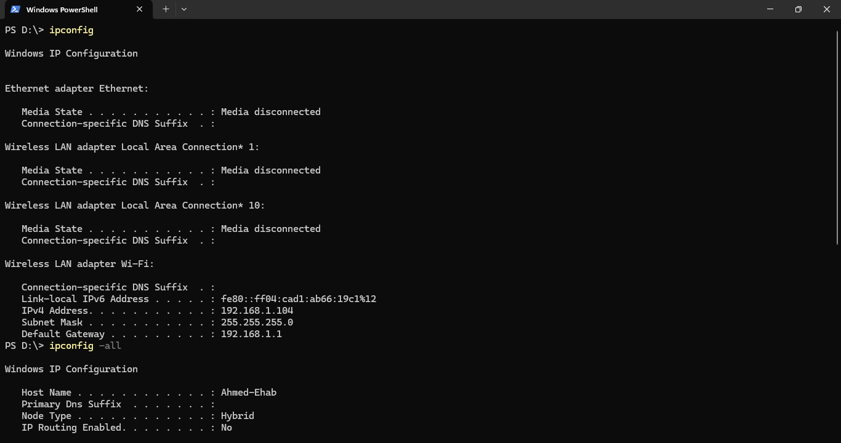
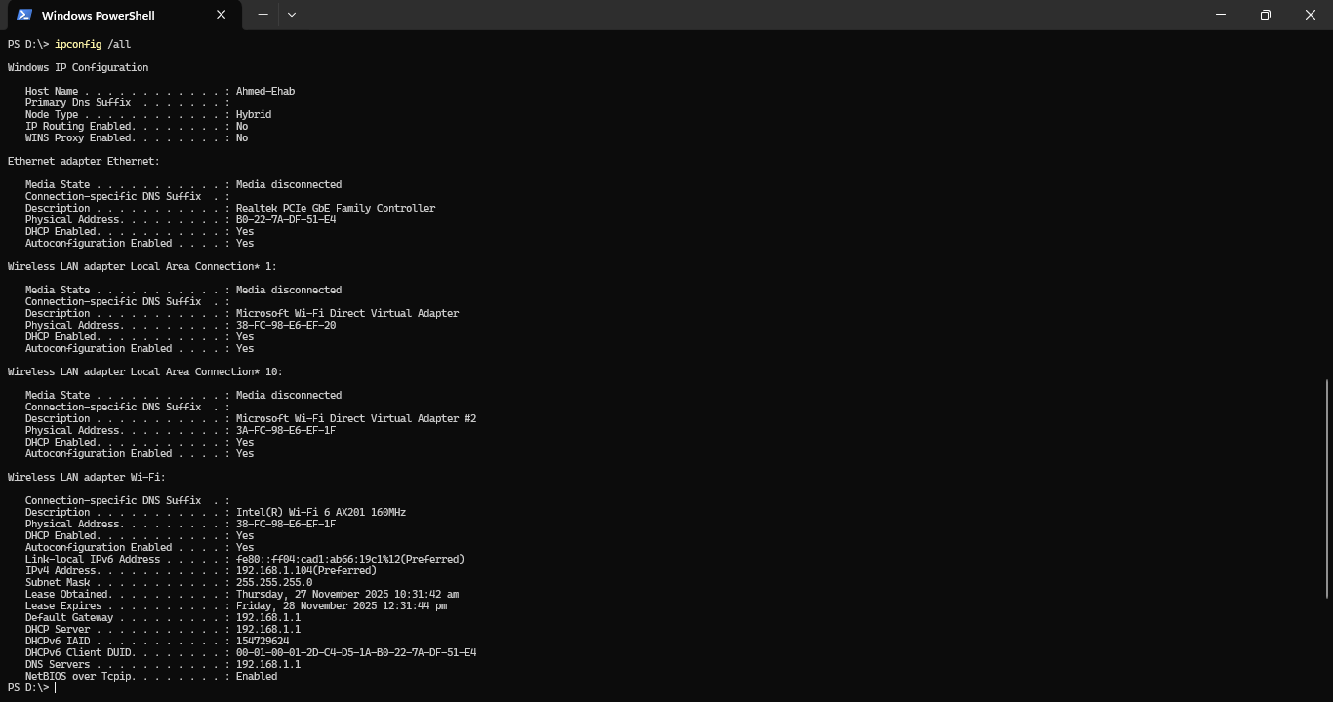
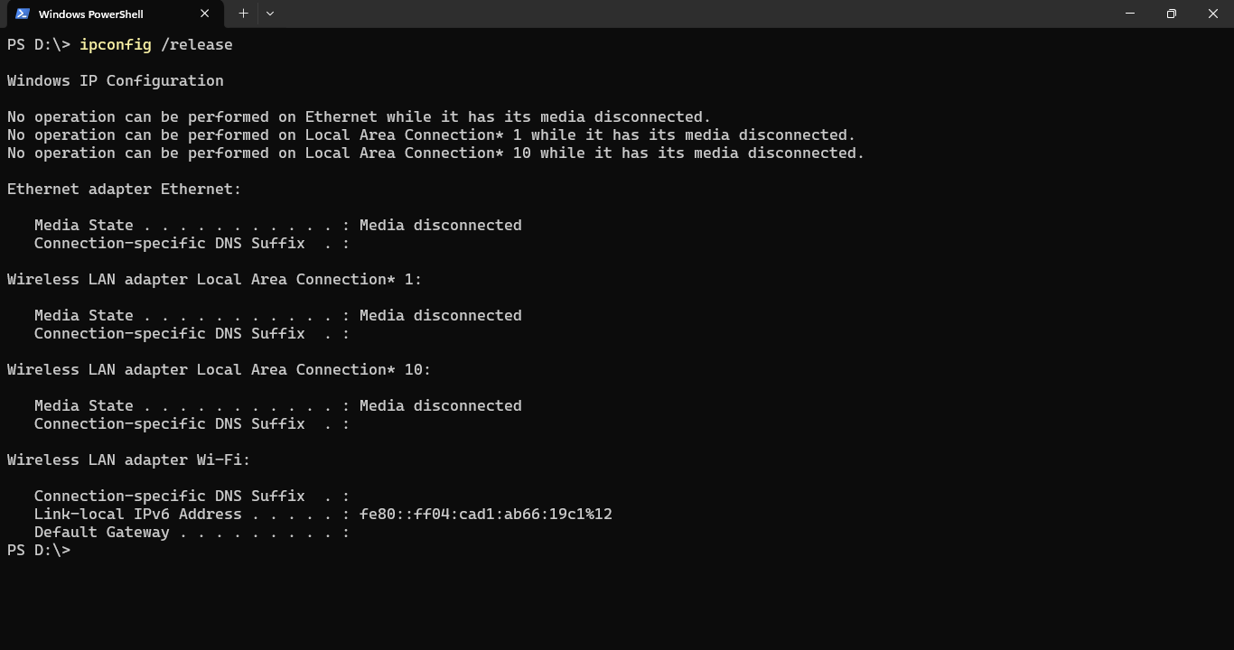
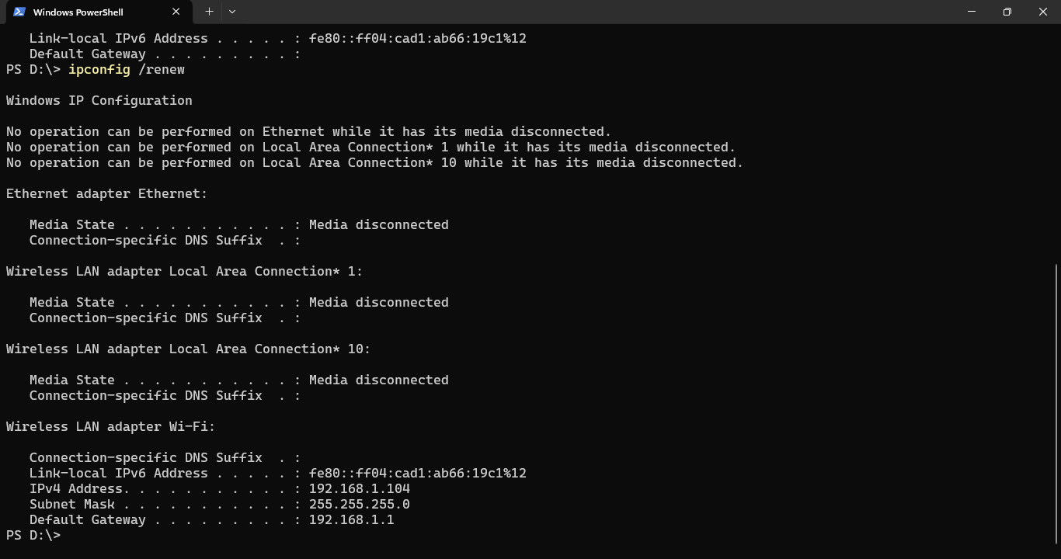
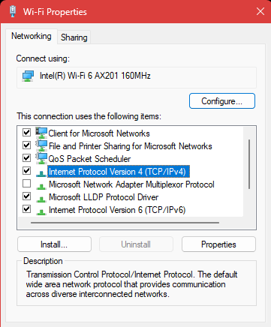
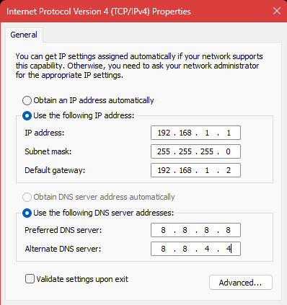
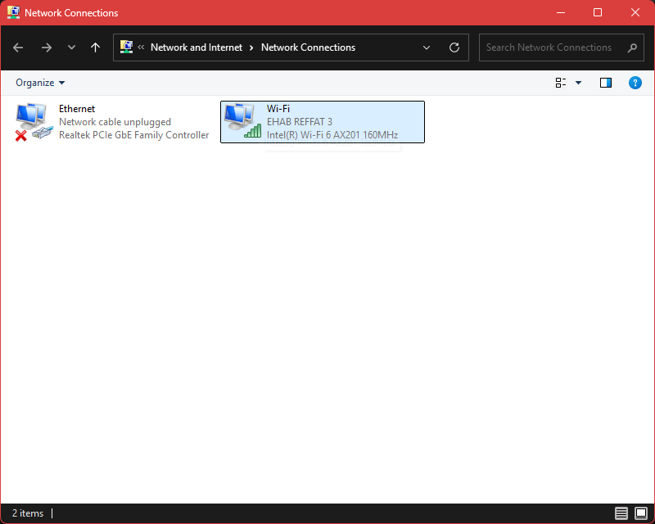

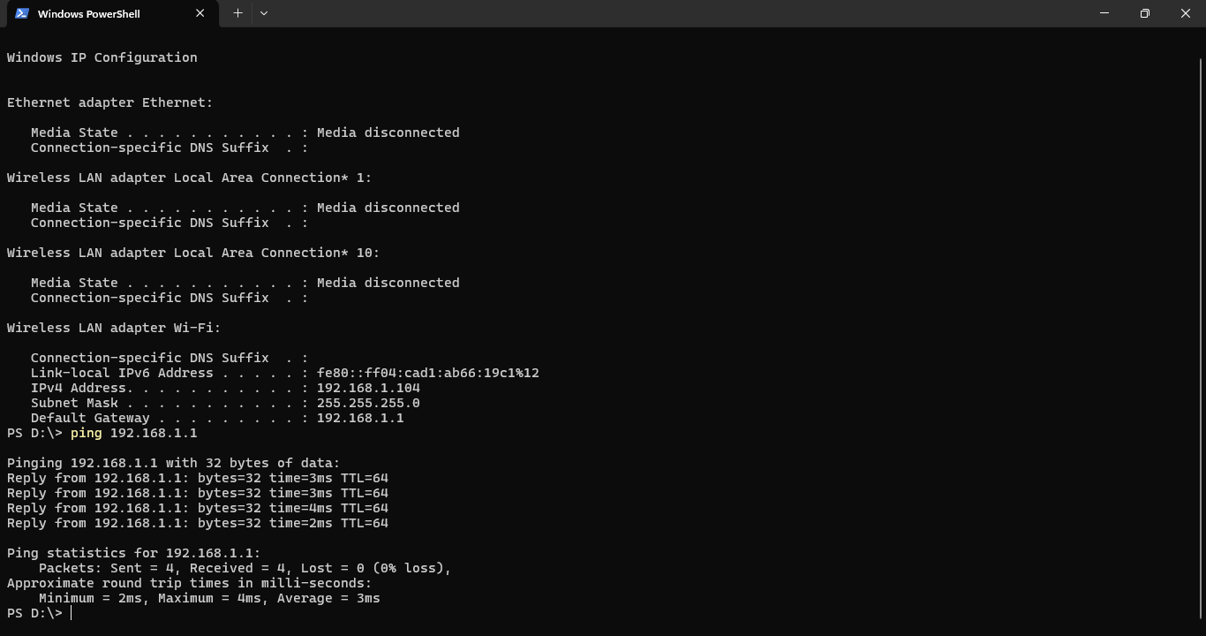

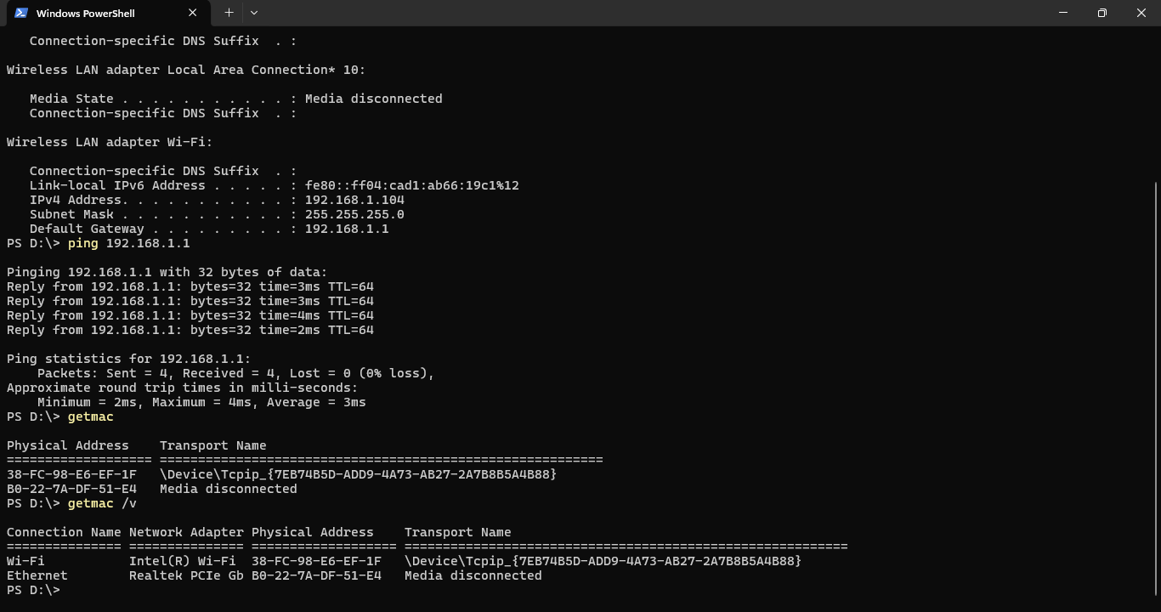
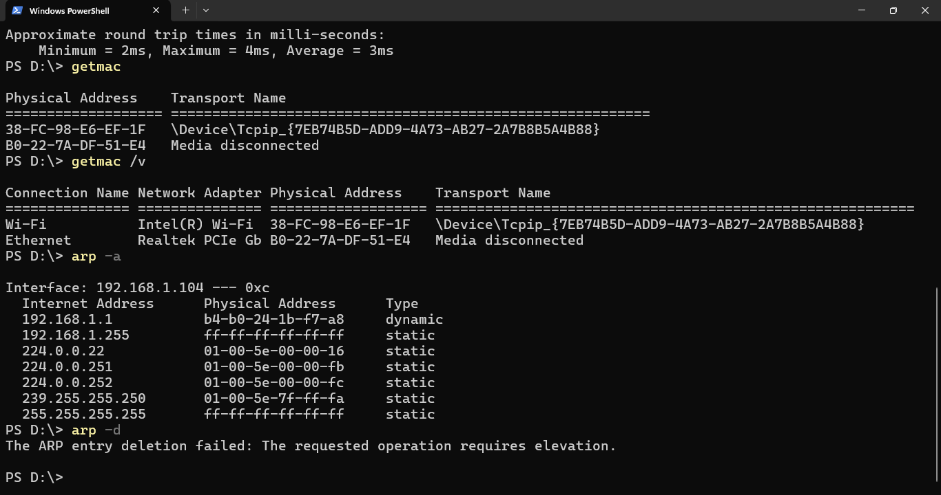

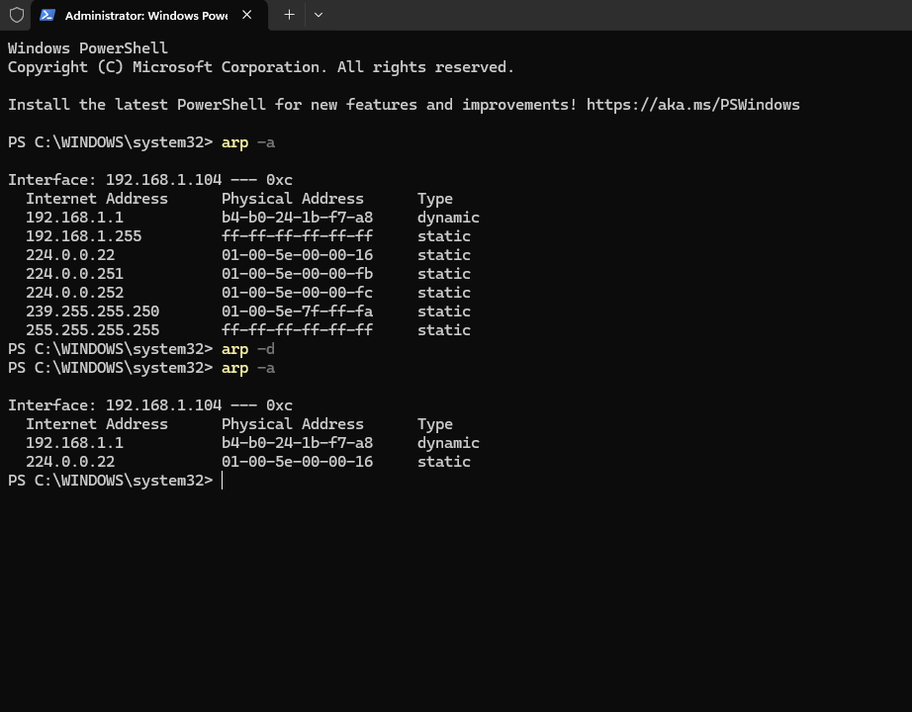
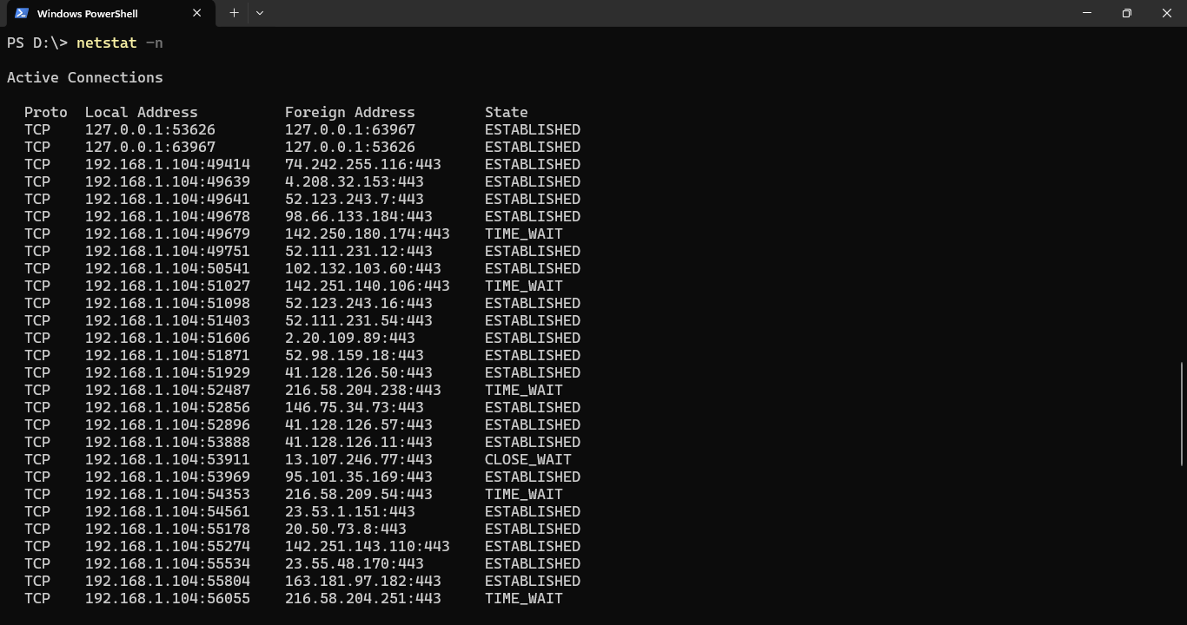
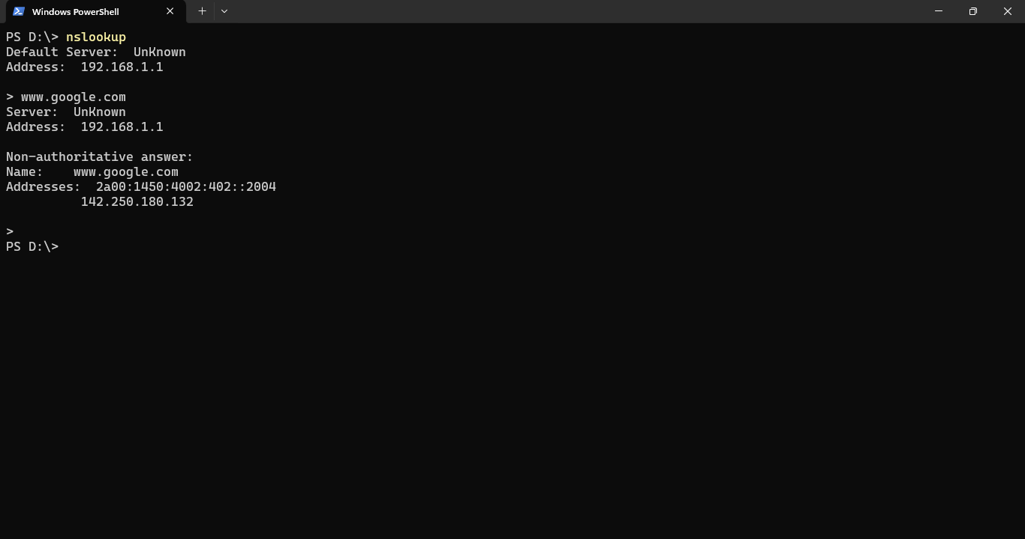
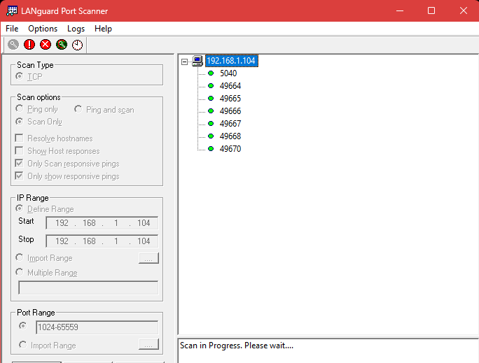

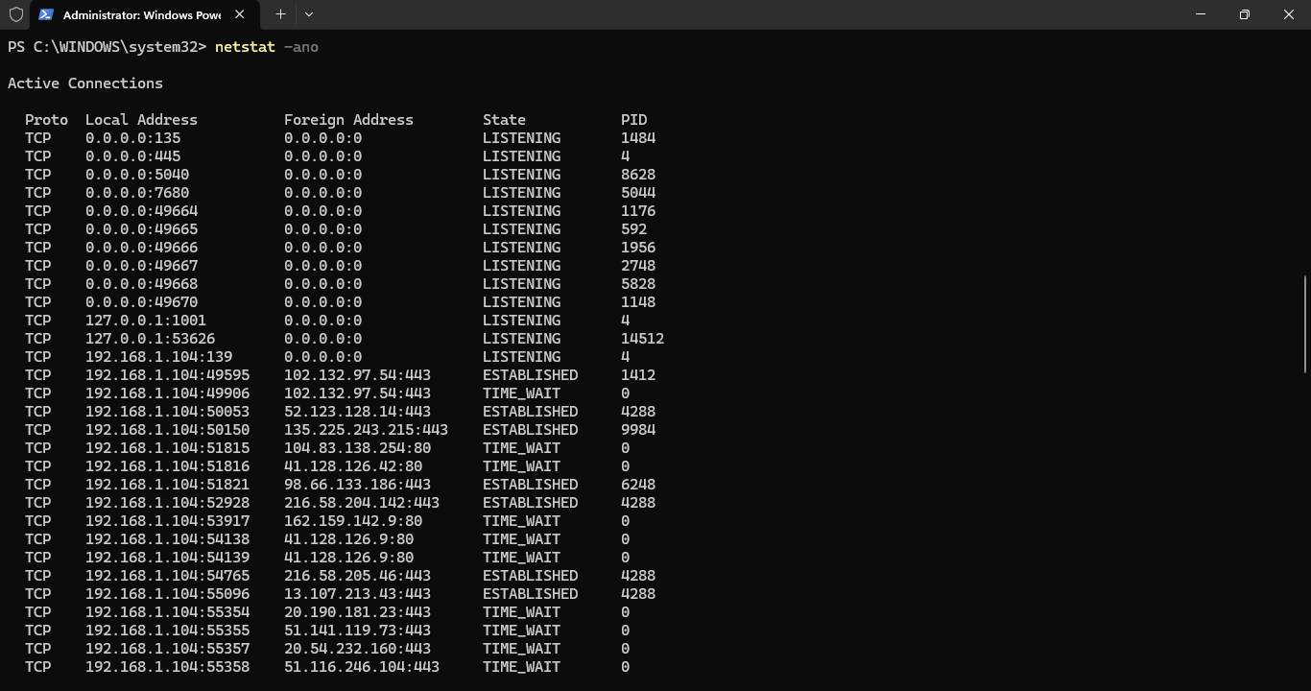
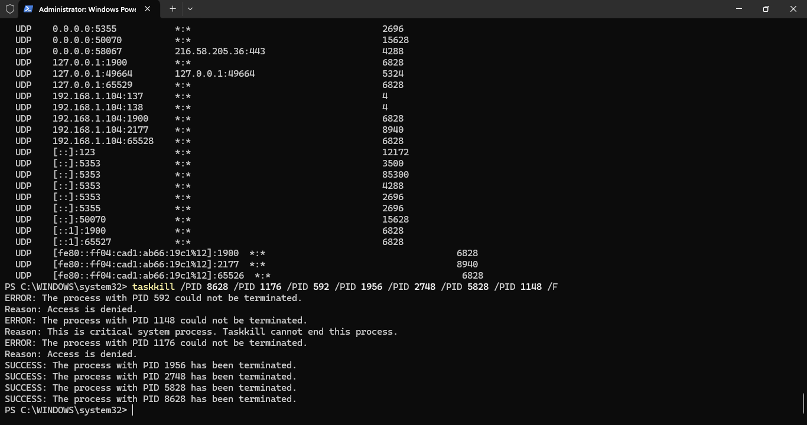

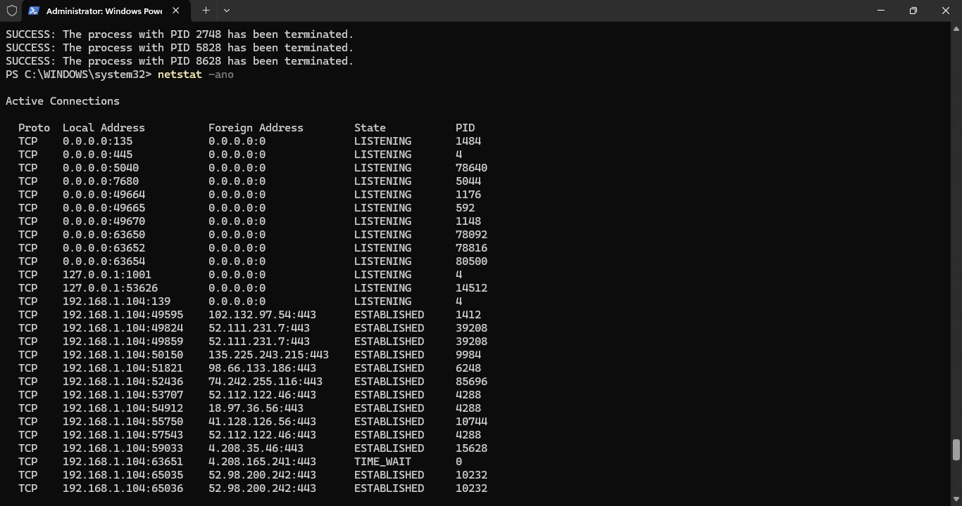
Port 5040:
Why It's Open
Part of the Windows Diagnostics Hub, used by developers and system administrators to collect logs and diagnostic info remotely.

Common Risks
- Information Leakage: Can expose detailed system logs and telemetry.
- Privilege Escalation: Debug services can sometimes be misused for local privilege escalation.
- Poor Access Controls: Not always well protected in default setups.

Port 49666:
Why It's Open
Port 49666 is in the dynamic/ephemeral port range and is commonly used by Windows RPC services, malware command and control, backdoor applications, and dynamic service bindings. The "666" suffix makes it particularly suspicious as it's often chosen by malicious software for psychological impact or to evade basic filtering rules.
Common Risks
- Malware command and control
Port commonly used by trojans and backdoors for remote access
- Windows RPC exploitation
Remote Procedure Call vulnerabilities may allow system compromise
- Data exfiltration
Malicious software may use this port to steal sensitive information
- Unauthorized remote access
Attackers may establish persistent backdoor connections
- Dynamic service binding abuse
Legitimate services may be hijacked or impersonated
- Network reconnaissance
Port scanning may reveal active Windows services
- Covert communication channels
Attackers may use high ports to avoid detection

